**Micheal JW Ellis Sr.**

[mike.ellis88@gmail.com](mailto:mike.ellis88@gmail.com) | 419-810-5050 | Toledo, OH

[LinkedIn](http://www.linkedin.com/in/michealjwellissr) | [GitHub](https://github.com/MichealJWEllis) | [Portfolio](https://michealjwellis.github.io/NewPortfolio/)

**Professional Summary:**

Full Stack Developer / Software Developer / IT Analyst with 10 + years of hands-on experience in designing, developing, and implementing applications and solutions using a range of technologies and programming languages. Seeking to leverage development experience and hands-on IT expertise in a challenging role as a Full-stack Developer. Current career responsibilities include, but not limited to, rebuilding and maintaining entire front-end experience with a mobile-first responsive design including back-end development for communication and functionality. Expanding sales opportunities by building custom platforms and management of version control operations via GIT.

**Skill Set:**

|  |  |  |  |  |  |
| --- | --- | --- | --- | --- | --- |
| * Node.JS | * Express | * JavaScript | * JQuery | * ReactJS | * IIS |
| * JSX | * GIT | * GitHub | * MongoDB | * MySQL | * HeidiSQL |
| * Mongoose | * Handlebars | * HTML5 | * CSS3 | * Bootstrap | * Materialize |
| * API’s | * Heroku | * Terminal | * AJAX | * Restful API | * ES6 |
| * Mithril | * JSON | * Sequelize | * GraphQL | * WebPack | * OOP |
| * C# | * ASP.NET | * CMD | * Linux | * Bash | * MERN |
| * Windows Office | * Networking | * PowerShell | * Python | * AWS |  |

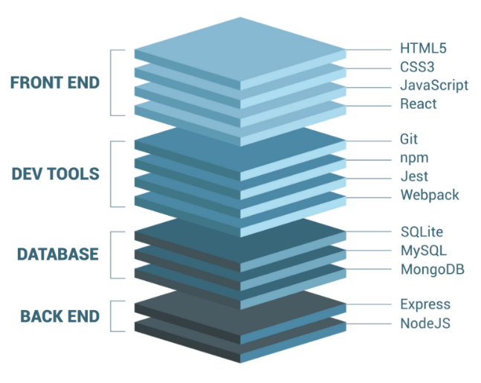**Experience:**

*(Web Developer / Full Stack Developer)*

Kwest Group_________________________________ May 22, 2022 – Present

8305 Fremont Pike Supervisor: Aaron Maupin

Perrysburg, OH 43551 [aaronmaupin@kwestgroup.com](mailto:aaronmaupin@kwestgroup.com)

PH: (419) 874-4284

*(Software Engineer / Full Stack Developer)*

Erie Construction ______________________________ August 17,2020 – May 20, 2022

3516 Granite Circle Supervisor: Tim Sink

Toledo, OH 43617 [tim@erieconstruction.com](mailto:tim@erieconstruction.com)

PH: (419) 472-4200

*(I.T / Help-desk Analyst /CAD Operator / 3rd Shift Supervisor)*

Alro Steel Inc._________________________________ March 18, 2013 – August 14, 2020

1605 Executive Dr. Supervisor: Chuck Houghton

1800 W. Willow St. Supervisor: Jamie Gaskill

Lansing, MI 48915 [jgaskill@alro.com](mailto:jgaskill@alro.com)

Jackson, MI 49204 [choughton@alro.com](mailto:choughton@alro.com)

PH: (517) 788-3131

**Education:**

****Coding Boot Camp Certification** The University of Texas at Austin

Achieved: July 2021 Main Building (MAI)

110 Inner Campus Drive

Austin, TX 78705

Ph: (512) 471 - 3434



**Associate of Applied Science: CAD Technology** Owens Community College

Certified CAD Technician 30335 Oregon Rd,

Achieved: May 2012 Perrysburg, OH 43551

Ph: (567) 661 - 7000

References provided on request.